t-Test
This example teaches you how to perform a t-Test in Excel. The t-Test is used to test the null hypothesis that the means of two populations are equal.
Below you can find the study hours of 6 female students and 5 male students.
H₀: μ₁ - μ₂ = 0
H₁: μ₁ - μ₂ ≠ 0
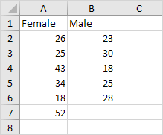
To perform a t-Test, execute the following steps.
1. First, perform an F-Test to determine if the variances of the two populations are equal. This is not the case.
2. On the Data tab, in the Analysis group, click Data Analysis.
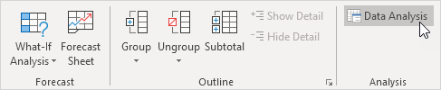
Note: can't find the Data Analysis button? Click here to load the Analysis ToolPak add-in.
3. Select t-Test: Two-Sample Assuming Unequal Variances and click OK.
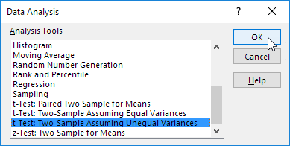
4. Click in the Variable 1 Range box and select the range A2:A7.
5. Click in the Variable 2 Range box and select the range B2:B6.
6. Click in the Hypothesized Mean Difference box and type 0 (H₀: μ₁ - μ₂ = 0).
7. Click in the Output Range box and select cell E1.
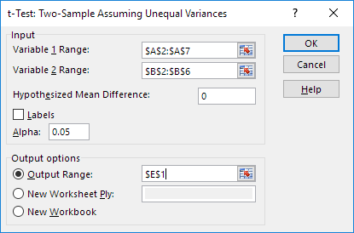
8. Click OK.
Result:
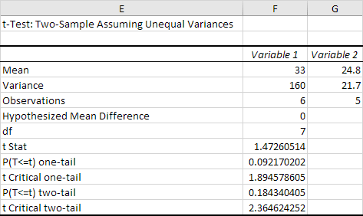
Conclusion: We do a two-tail test (inequality). lf t Stat < -t Critical two-tail or t Stat > t Critical two-tail, we reject the null hypothesis. This is not the case, -2.365 < 1.473 < 2.365. Therefore, we do not reject the null hypothesis. The observed difference between the sample means (33 - 24.8) is not convincing enough to say that the average number of study hours between female and male students differ significantly.
Before you run any statistical test, you must first determine your alpha level, which is also called the “significance level.” By definition, the alpha level is the probability of rejecting the null hypothesis when the null hypothesis is true. Translation: It's the probability of making a wrong decision.
Refer Table-F Page – 784 (Elementary Statistics by Bluman.pdf)
Refer Table-F Page – 784 (Elementary Statistics by Bluman.pdf) for t Critical two-tail 2.26215716279821 and theory at Page-484.

